

AIL 202

DATABASE MANAGEMENT SYSTEMS LAB

LAB MANUAL STUDENT’S

Name of the Student : Gokul P

Roll No : ASI23CA032

Semester and Brach of Study : S4 CSE-AI

# ASIET VISION

● To emerge as a Center of Excellence in Engineering, Technology and Management by imparting quality education, focusing on empowerment and innovation.

# ASIET MISSION

* Impart quality professional education for total upliftment of the society.
* Create congenial academic ambience that kindles innovative thinking and research.
* Mould competent professionals who are socially committed and responsible citizens.

# VISION OF THE DEPARTEMENT

● To be in the frontier of AI technology through quality of education, collaborative research and produce globally competitive, industry ready engineers with social commitment.

# MISSION OF THE DEPARTEMENT

* Achieve excellence in the educational experience, fostering collaborative research through state-of-the-art infrastructure and innovative elements.
* Establish industry collaboration to address interdisciplinary challenges across diverse applications.
* Inspire students to develop into ethical, Innovative and entrepreneurial leaders through a socially-centered program.

# COURSE SYLLABUS

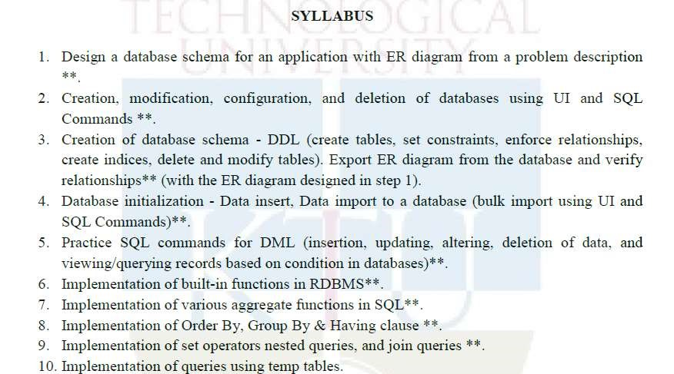

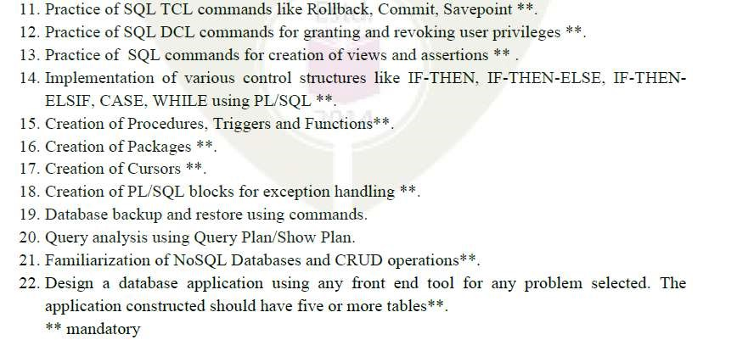

Text Books

1. Elmasri R. and S. Navathe, Database Systems: Models, Languages, Design and Application Programming, Pearson Education, 2013.
2. Sliberschatz A., H. F. Korth and S. Sudarshan, Database System Concepts, 6/e, McGraw Hill, 2011.

References

1. Adam Fowler, NoSQL for Dummies, John Wiley & Sons, 2015
2. NoSQL Data Models: Trends and Challenges (Computer Engineering: Databases and Big Data), Wiley, 2018

# COURSE OUTCOMES

After the completion of this course, students shall be able to:

|  |  |  |
| --- | --- | --- |
| CO No. | Course Outcome | Knowledge Level |
| CO1 | Design database schema for a given real world problemdomain using standard design and modeling approaches. | Applying (K3) |
| CO2 | Construct queries using SQL for database creation, interaction, modification, and updation | Applying (K3) |
| CO3 | Design and implement triggers and cursors. | Applying (K3) |
| CO4 | Implement procedures, functions, and control structures using PL/SQL. | Applying (K3) |
| CO5 | Perform CRUD operations in NoSQL Databases. | Applying (K3) |
| CO6 | Develop database applications using front-end tools and back-end DBMS. | Create() |

CO-PO and CO-PSO mapping :

|  |  |  |  |  |  |  |  |  |  |  |  |  |  |  |
| --- | --- | --- | --- | --- | --- | --- | --- | --- | --- | --- | --- | --- | --- | --- |
| CO\PO  &PSO | PO1 | PO  2 | PO  3 | PO  4 | PO  5 | PO  6 | PO  7 | PO  8 | PO  9 | PO1  0 | PO1  1 | PO1  2 | PSO  1 | PSO  2 |
| 1 | 2 | 2 | 2 |  | 2 |  |  | 2 |  | 2 |  | 2 |  |  |
| 2 | 3 | 2 | 3 |  | 1 |  |  | 2 |  | 2 |  | 2 |  |  |
| 3 | 3 | 2 | 2 | 2 | 2 |  |  | 2 |  | 1 |  | 2 |  |  |
| 4 | 3 | 3 | 2 | 2 | 1 |  |  | 2 |  | 2 |  | 2 |  |  |
| 5 | 3 | 3 | 1 |  | 1 |  |  | 2 |  | 2 |  | 1 |  |  |
| 6 | 3 | 3 | 1 | 1 | 2 | 1 |  | 2 | 1 | 2 | 2 | 1 |  |  |

1-Slightly, 2-Moderately, 3-Strongly

# GENERAL INSTRUCTIONS (for the lab)

1. During the lab hours, upon the completion of an experiment, ask your Staff in charge to verify your results. DO NOT PROCEED to the next experiment until the Staff in charge has verified and taken note of your results. These observations will be used to determine your in-lab performance.
2. Upon completion of an experiment, students will submit their individual lab journal along with their observations(input and output) /inferences to their respective staff in charges and get it signed.
3. Make up for an experiment will be granted for excused absences. In such a case, the experiment must be completed as soon as possible so that it will not interfere with the normal lab schedule. Furthermore, any student who has missed any lab due to an excused absence, is required to complete the experiment individually.
4. If an individual cannot complete the experiment due to equipment malfunction or other unforeseen situation, students are allowed to attend other lab sessions for that week, if space is available. If space cannot be found, then students can complete their work in the following week. However, every effort must be made to complete the experiment during its designated week.
5. Finally, any unexcused absence results in a grade of 0 for the lab. Weekly attendance for this lab is mandatory. Habitually late students (i.e., students late more than 15 minutes more than once) will receive point reductions in their grades for each occurrence.
6. Assessment Method: The Academic Assessment for the Programming lab will be done internally by the College. There will be a final Practical Exam out of 25 marks (internal by the College). The total marks for the lab obtained out of 50 will be converted into equivalent proportion out of 20 for Continuous Internal Evaluation (CIE) computation. Exams are taken individually and not as a team.

# INDEX

|  |  |  |
| --- | --- | --- |
| 1 | Design a database schema for an application with ER diagram from a problem description | CO1 |
| 2 | Creation, modification, configuration, and deletion of databases using UI and SQL Commands **. | CO2 |
| 3 | Creation of database schema - DDL (create tables, set constraints, enforce relationships,  create indices, delete and modify tables). Export ER diagram from the database and verify relationships** (with the ER diagram designed in step 1). | CO2 |
| 4 | Database initialization - Data insert, Data import to a database (bulk import using UI and SQL Commands)**. | CO2 |
| 5 | Practice SQL commands for DML (insertion, updating, altering, deletion of data, and viewing/querying records based on condition in databases)**. | CO2 |
| 6 | Implementation of built-in functions in RDBMS**. | CO2 |
| 7 | Implementation of various aggregate functions in SQL**. | CO2 |
| 8 | Implementation of Order By, Group By & Having clause **. | CO2 |
| 9 | Implementation of set operators nested queries, and join queries **. | CO2 |
| 10 | Implementation of queries using temp tables. | CO2 |
| 11 | Practice of SQL TCL commands like Rollback, Commit, Savepoint **. | CO2 |
| 12 | Practice of SQL DCL commands for granting and revoking user privileges **. | CO2 |
| 13 | Practice of SQL commands for creation of views and assertions ** . | CO2 |
| 14 | Implementation of various control structures like IF-THEN, IF-THEN-ELSE, IFTHENELSIF, CASE, WHILE using PL/SQL **. | CO4 |
| 15 | Creation of Procedures, Triggers and Functions**. | CO3,C O4 |
| 16 | Creation of Packages **. | CO4 |
| 17 | Creation of Cursors **. | CO3 |
| 18 | Creation of PL/SQL blocks for exception handling **. | CO4 |
| 19 | Database backup and restore using commands | CO2 |
| 20 | Query analysis using Query Plan/Show Plan | CO2 |
| 21 | Familiarization of NoSQL Databases and CRUD operations**. | CO5 |
| 22 | Design a database application using any front end tool for any problem selected. The application constructed should have five or more tables**. | CO6 |

# CYCLE 1

EXP NO: 1

Design a database schema for an application with ER diagram from a problem description AIM:

To design a database schema for an application with ER diagram from a problem description

THEORY:

The ER model represents real world situations using concepts, which are commonly used by people. It allows defining a representation of the real world at logical level

* Entity: An entity is something which is described in the database by storing its data, it may be a concrete entity or a conceptual entity.
* Entity set: An entity set is a collection of similar entities.
* Attribute: An attribute describes a property associated with entities. Attribute will have a name and a value for each entity.
* Domain: A domain defines a set of permitted values for an attribute

## SYMBOLS IN E-R DIAGRAM

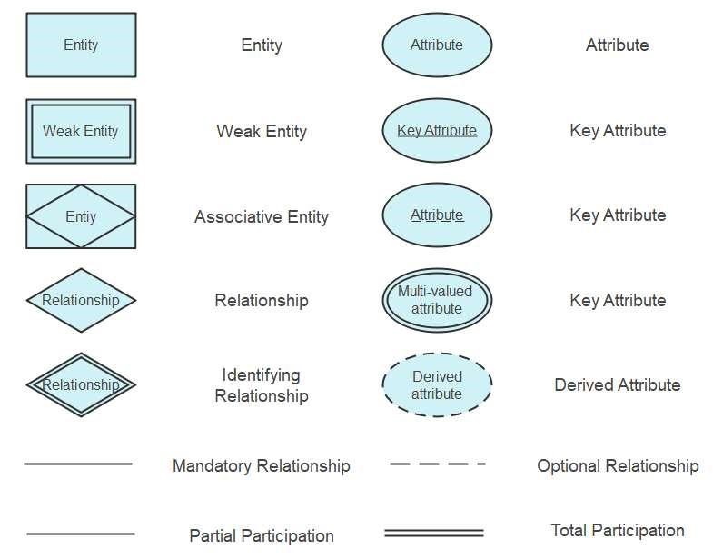

Problem 1:

The COMPANY database keeps track of a company’s employees, departments, and projects. Suppose that after the requirements collection and analysis phase, the database designers provide the following description of the miniworld—the part of the company that will be represented in the database.

* The company is organized into departments. Each department has a unique name, a unique number, and a particular employee who manages the department. We keep track of the start date when that employee began managing the department. A department may have several locations.
* A department controls a number of projects, each of which has a unique name, a unique number, and a single location.
* We store each employee’s name, Social Security number,address, salary, sex (gender), and birth date. An employee is assigned to one department, but may work on several projects, which are not necessarily controlled by the same department. We keep track of the current number of hours per week that an employee works on each project. We also keep track of the direct supervisor of each employee (who is another employee). ● We want to keep track of the dependents of each employee for insurance purposes. We keep each dependent’s first name, sex, birth date, and relationship to the employee.

Problem 2:

The Library Management System database keeps track of readers with the following considerations –

* The system keeps track of the staff with a single point authentication system comprising login Id and password.
* Staff maintains the book catalog with its ISBN, Book title, price(in INR), category(novel, general, story), edition, author Number and details.
* A publisher has publisher Id, Year when the book was published, and name of the book.
* Readers are registered with their user_id, email, name (first name, last name), Phone no (multiple entries allowed), communication address. The staff keeps track of readers.
* Readers can return/reserve books that stamps with issue date and return date. If not returned within the prescribed time period, it may have a due date too.
* Staff also generate reports that has readers id, registration no of report, book no and return/issue info.

Question :

* 1. Draw ER diagrams for both problem description

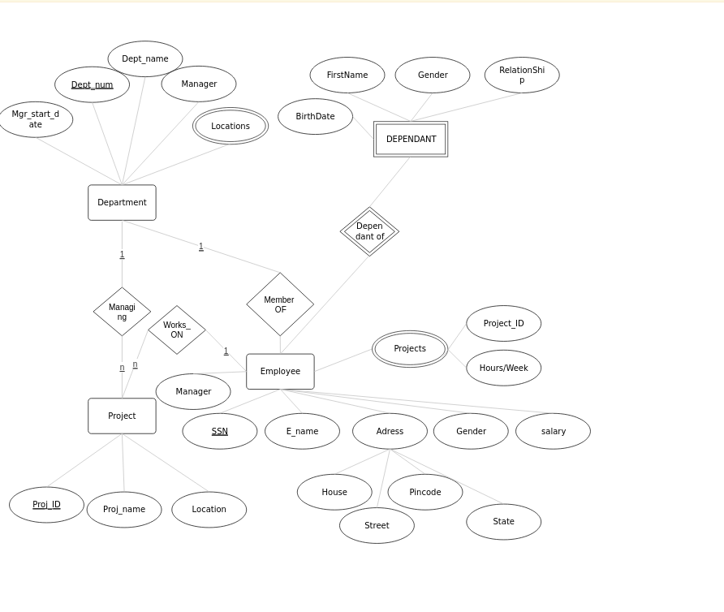

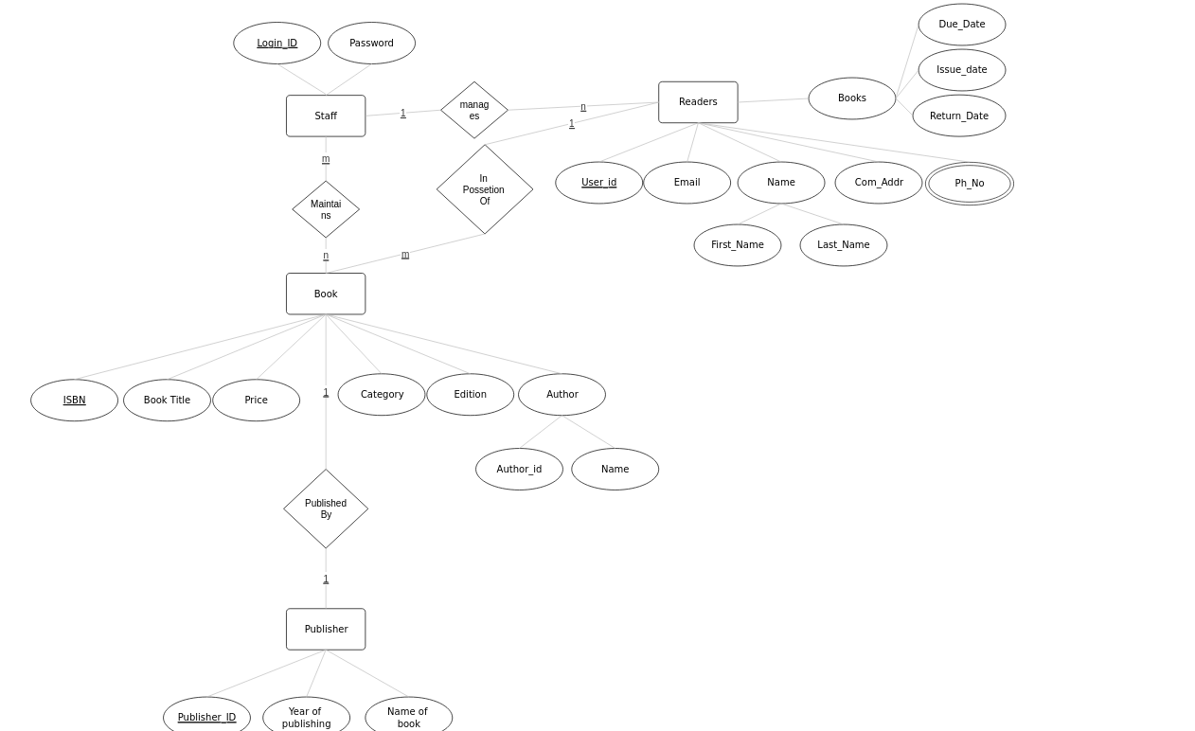

RESULT

Designed ER Diagrams for both problem descriptions

EXP NO: 2

Creation, modification, configuration, and deletion of databases

Commands

AIM:

To creation, modification, configuration, and deletion of databases using UI and SQL

Commands COMMANDS

THEORY

1. CREATE DATABASE

The CREATE DATABASE statement is used to create a new SQL database.

SYNTAX

CREATE DATABASE <databasename>

EXAMPLE

Create database CMS

1. DROP DATABASE

The DROP DATABASE statement is used to drop an existing SQL database.

SYNTAX

DROP DATABASE <databasename>

EXAMPLE

Drop database CMS

1. USE DATABSE

This will display the database created

SYNTAX : Use <database name>

EXAMPLE : Use CMS

Questions:

1. Create a database for company Management System(CMS)



1. A close up of black text

   AI-generated content may be incorrect.Drop database

1. Rename any database created

RENAME CMS CMS2;

1. Use database

1. **A computer code with text

   Description automatically generated with medium confidence**Describe database

RESULT

Created and used CMS database succesfully. DDL commands Exected succesfully and desired output is recived.

EXP NO: 3

Applications of DDL Commands Using UI and SQL

Aim

Creation of database schema - DDL (create tables, set constraints, enforce relationships, create indices, delete and modify tables).

THEORY

1. CREATE TABLE

The CREATE TABLE statement is used to create a new table in a database.

SYNTAX

CREATE TABLE table_name ( column1 datatype, column2 datatype, column3 datatype, ....

### );

1. ALTER TABLE

The ALTER TABLE statement is used to add, delete, or modify columns in an existing table.

The ALTER TABLE statement is also used to add and drop various constraints on an existing table.

SYNTAX

* + 1. ALTER TABLE table_name ADD column_name datatype;
    2. ALTER TABLE table_name DROP COLUMN column_name;
    3. ALTER TABLE table_name RENAME COLUMN old_name to new_name;

1. MODIFY TABLE

1. ALTER TABLE table_name MODIFY COLUMN column_name datatype;

1. DROP TABLE

The DROP TABLE statement is used to drop an existing table in a database.

1. DROP TABLE table_name;

1. TRUNCATE TABLE

The TRUNCATE TABLE statement is used to delete the data inside a table, but not the table itself. 1. TRUNCATE TABLE table_name;

SQL Constraints

SQL constraints are used to specify rules for the data in a table.

Constraints are used to limit the type of data that can go into a table. This ensures the accuracy and reliability of the data in the table. If there is any violation between the constraint and the data action, the action is aborted.

Constraints can be column level or table level. Column level constraints apply to a column, and table level constraints apply to the whole table.

The following constraints are commonly used in SQL:

* + NOT NULL - Ensures that a column cannot have a NULL value
  + UNIQUE - Ensures that all values in a column are different
  + PRIMARY KEY - A combination of a NOT NULL and UNIQUE. Uniquely identifies each row in a table
  + FOREIGN KEY - Prevents actions that would destroy links between tables
  + CHECK - Ensures that the values in a column satisfies a specific condition
  + DEFAULT - Sets a default value for a column if no value is specified
  + CREATE INDEX - Used to create and retrieve data from the database very quickly

1. Create following tables based on the description provided in Exp 1
   1. Department Table:

 Attributes: DepartmentID (Primary Key), Name, Number, ManagerID (Foreign Key referencing Employee), StartDate, Location

* 1. Project Table: Attributes: ProjectID (Primary Key), Name, Number, Location, DepartmentID (Foreign Key referencing Department)
  2. Employee Table:

Attributes: EmployeeID (Primary Key), Name, SSN, Address, Salary, Gender, BirthDate, Role, DepartmentID (Foreign Key referencing

Department), SupervisorID (Foreign Key referencing Employee)

* 1. ProjectAssignment Table:

Attributes: AssignmentID (Primary Key), EmployeeID (Foreign Key referencing Employee), ProjectID (Foreign Key referencing Project),

HoursPerWeek

* 1. Dependent Table:

 Attributes: DependentID (Primary Key), EmployeeID (Foreign Key referencing Employee), FirstName, Gender, BirthDate, Relationship

1. A screenshot of a computer program

   AI-generated content may be incorrect.Alter tables to add appropriate constraints

RESULT

Created Tables with appropriate constraints successfully.

## EXP NO: 4

Database initialization - Data insert, Data import to a database (bulk import using UI and SQL Commands).

AIM

To insert data to tables used in experiment no 3 using insert commands and bulk import using UI and sql commands.

THEORY

The INSERT INTO statement is used to insert new records in a table.

INSERT:

1. INSERT INTO table_name (column1, column2, column3,.) VALUES (value1, value2, value3, ...);
2. INSERT INTO table_name

VALUES (value1, value2, value3, ...);

QUERIES

1. A close-up of a computer code

   AI-generated content may be incorrect.Insert appropriate values to all tables created in Exp No. 3

RESULT

Data inserted into Tables successfully.

## EXP NO: 5

DML Commands

AIM

Practice SQL commands for DML (insertion, updating, altering, deletion of data, and viewing/querying records based on condition in databases)

THEORY SELECT:

1. SELECT column1, column2, .. FROM table_name;
2. SELECT DISTINCT column1, column2, ...

FROM table_name; (Shows only unique rows)

1. SELECT column1, column2, ... FROM table_name WHERE condition; (Where is used to filter records)
2. SELECT column1, column2, ... FROM table_name

ORDER BY column1, column2, ... ASC|DESCINSERT : ( will sort the columns in ascending or descending order)

1. SELECT column1, column2, ... FROM table_name

WHERE columnN LIKE pattern;

UPDATE:

1. PDATE table_name

SET column1 = value1, column2 = value2, ... WHERE condition;

DELETE:

1. DELETE FROM table_name WHERE condition;

Algorithm:

Consider the employee database created. Find the following

1. Find the names of all employees who work for SBI.

1. Find all employees in the database who live in the same cities as the companies for which they work.

1. Find all employees and their managers in the database who live in the same cities and on the same street number as do their managers.

1. Find all employees who earn more than the average salary of all employees of their

Company.

1. Find the company that pays the least total salary along with the salary paid.

1. Give all managers of SBI a 10 percent raise.

1. Find the company that has the most employees

1. A close-up of a white background

   AI-generated content may be incorrect.Find those companies whose employees earn a higher salary, on average than the average salary at Indian Bank.

1. Change the department of one employee to another.

1. Remove employee with ID 203 from the database.

RESULT

Thus the DML was performed successfully and executed.

EXP NO: 6

Implementation of Built In Functions AIM:

Implementation of built in functions in RDBMS

Theory

RDBMS Built in Functions

There are two types of functions:

1. Single Row Functions: Single row or Scalar functions return a value for every row that is processed in a query.
2. Group Functions: These functions group the rows of data based on the values returned by the query. This is discussed in SQL GROUP Functions. The group functions are used to calculate aggregate values like total or average, which return just one total or one average value after processing a group of rows.

There are four types of single row functions. They are:

1. Numeric Functions: These are functions that accept numeric input and return numeric values.
2. Character or Text Functions: These are functions that accept character input and can return both character and number values.
3. Date Functions: These are functions that take values that are of datatype DATE as input and return values of datatype DATE, except for the MONTHS_BETWEEN function, which returns a number.
4. Conversion Functions: These are functions that help us to convert a value in one form to another form. For Example: a null value into an actual value, or a value from one datatype to another datatype like NVL, TO_CHAR, TO_NUMBER, TO_DATE etc.

You can combine more than one function together in an expression. This is known as nesting of functions.

* 1. Numeric Functions:

Numeric functions are used to perform operations on numbers. They accept numeric values as input and return numeric values as output. Few of the Numeric functions are:

|  |  |
| --- | --- |
| Function Nam | e Return Value |
| ABS (x) | Absolute value of the number 'x' |
| CEIL (x) | Integer value that is Greater than or equal to the number 'x' |
| FLOOR (x) | Integer value that is Less than or equal to the number 'x' |
| TRUNC (x, y) | Truncates value of number 'x' up to 'y' decimal places |
| ROUND (x, y) | Rounded off value of the number 'x' up to the number 'y' decimal places |

The following examples explains the usage of the above numeric functions :

|  |  |  |
| --- | --- | --- |
| Function Name | Examples | Return Value |
| ABS (x) | ABS (1)  ABS (-1) | 1  -1 |
|  | CEIL (2.83) | 3 |
| CEIL (x) | CEIL (2.49) CEIL (-1.6) | 3  -1 |
|  | FLOOR (2.83) | 2 |
| FLOOR (x) | FLOOR (2.49) FLOOR (-1.6) | 2  -2 |
|  | ROUND (125.456, 1) | 125.4 |
| ROUND (x, y) | ROUND (125.456, 0) | 125 |
|  | ROUND (124.456, -1) | 120 |

* 1. Character or Text Functions:

Character or text functions are used to manipulate text strings. They accept strings or characters as input and can return both character and number values as output.

Few of the character or text functions are as given below:

|  |  |
| --- | --- |
| Function Name | Return Value |
| LOWER (string_value) | All the letters in 'string_value' is converted to lowercase. |
| UPPER (string_value) | All the letters in 'string_value' is converted to uppercase. |
| LTRIM (string_value, trim_text) | All occurrences of 'trim_text' is removed from the left of 'string_value'. |
| RTRIM (string_value, trim_text) | All occurrences of 'trim_text' is removed from the right of 'string_value' . |
| TRIM (trim_text FROM string_value) | All occurrences of 'trim_text' from the left and right of  'string_value' , 'trim_text' can also be only one character long . |
| SUBSTR (string_value, m, n) | Returns 'n' number of characters from 'string_value' starting from the 'm' position. |
| LENGTH (string_value) | Number of characters in 'string_value' in returned. |
| LPAD (string_value, n, pad_valu | eReturns 'string_value' left-padded with 'pad_value' . The length of the whole string will be of 'n' characters. |
| RPAD (string_value, n, pad_valu | eReturns 'string_value' right-padded with 'pad_value' . The length  of whole string will be of ‘n’ characters. |

For Example, we can use the above UPPER() text function with the column value as follows. SELECT UPPER (product_name) FROM product;

The following examples explains the usage of the above character or text functions

|  |  |  |
| --- | --- | --- |
| Function Name | Examples | Return Value |
| LOWER(string_value) | LOWER('Good Morning') | good morning |
| UPPER(string_value) | UPPER('Good Morning') | GOOD MORNING |
| INITCAP(string_value) | INITCAP('GOOD MORNING') | Good Morning |
| LTRIM(string_value, trim_text) | LTRIM ('Good Morning', 'Goo | dMorning |
| RTRIM (string_value, trim_text) | RTRIM ('Good  Morning', '  Morning') | Good |
| TRIM (trim_text FROM string_val | uTRIM ('o' FROM 'Good Morni | nGd Mrning |
| SUBSTR (string_value, m, n) | SUBSTR ('Good Morning', 6, 7 | Morning |
| LENGTH (string_value) | LENGTH ('Good Morning') | 12 |
| LPAD (string_value, n, pad_value) | LPAD ('Good', 6, '*') | **Good |
| RPAD (string_value, n, pad_value) | RPAD ('Good', 6, '*') | Good** |

* 1. Date Functions:

These are functions that take values that are of datatype DATE as input and return values of datatypes DATE, except for the MONTHS_BETWEEN function, which returns a number as output.

Few date functions are as given below:

|  |  |
| --- | --- |
| Function Name | Return Value |
| ADD_MONTHS (date, n) | Returns a date value after adding 'n' months to the date 'x'. |
| MONTHS_BETWEEN (x1, x2) | Returns the number of months between dates x1 and x2. |
| ROUND (x, date_format) | Returns the date 'x' rounded off to the nearest century, year, month, date, hour, minute, or second as specified by the 'date_format'. |
| TRUNC (x, date_format) | Returns the date 'x' lesser than or equal to the nearest century year, month, date, hour, minute, or second as specified by the 'date_format'. |
| NEXT_DAY (x, week_day) | Returns the next date of the 'week_day' on or after the date 'x' occurs. |
| LAST_DAY (x) | It is used to determine the number of days remaining in a month from the date 'x' specified. |
| SYSDATE | Returns the systems current date and time. |
| NEW_TIME (x, zone1, zone2) | Returns the date and time in zone2 if date 'x' represents the time in zone1. |

The below table provides the examples for the above functions

|  |  |  |
| --- | --- | --- |
| Function Name | Examples | Return Value |
| ADD_MONTHS ( ) | ADD_MONTHS ('16-Sep-81', 3) | 16-Dec-81 |
| MONTHS_BETWEEN( ) | MONTHS_BETWEEN('16-Sep-81',  '16-Dec-81') | 3 |
| NEXT_DAY( ) | NEXT_DAY ('01-Jun-08', 'Wednesday') | 04-JUN-08 |
| LAST_DAY( ) | LAST_DAY ('01-Jun-08') | 30-Jun-08 |
| NEW_TIME( ) | NEW_TIME ('01-Jun-08', 'IST', 'EST') | 31-May-08 |

* 1. Conversion Functions:

These are functions that help us to convert a value in one form to another form. For Ex: a null value into an actual value, or a value from one datatype to another datatype like NVL, TO_CHAR, TO_NUMBER, TO_DATE.

Few of the conversion functions available in oracle are:

|  |  |
| --- | --- |
| Function Name | Return Value |
| TO_CHAR (x [,y]) | Converts Numeric and Date values to a character string value. It cannot be used for calculations since it is a string value. |
| TO_DATE (x [, date_format]) | Converts a valid Numeric and Character values to a Date value.  Date is formatted to the format specified by 'date_format'. |
| NVL (x, y) | If 'x' is NULL, replace it with 'y'. 'x' and 'y' must be of the same datatype. |
| DECODE(a, b, c, d, e,  default_value) | Checks the value of 'a', if a = b, then returns 'c'. If a = d, then returns Else, returns default_value. |

The below table provides the examples for the above functions

|  |  |  |
| --- | --- | --- |
| Function Name | Examples | Return Value |
| TO_CHAR () | TO_CHAR (3000, '$9999')  TO_CHAR (SYSDATE, 'Day, Month YYYY' | $3000  Monday, June 2008 |
| TO_DATE () | TO_DATE ('01-Jun-08') | 01-Jun-08 |
| NVL () | NVL (null, 1) | 1 |
|  |  |  |

Queries:

Q1: Display all the details of the records whose employee name starts with ‘A’. Solution:

Q2: Display all the details of the records whose employee name does not start with ‘A’.



Q3: Display the rows whose salary ranges from 15000 to 30000.



Q4: Calculate the total and average salary amount of the emp table.

Q5: Count the total records in the emp table.

Q6: Determine the max and min salary and rename the column as max_salary and min_salary.

Q7: Display the month between “1-jun-10”and 1-aug-10 in full.

Q8: Display the last day of that month in “05-Oct-09”.

Q9: Find how many job titles are available in the employee table.

Q10: What is the difference between maximum and minimum salaries of employees in the organization?

RESULT

Thus the Queries using Built in functions were performed successfully and executed.

EXP NO: 7

Implementation of various aggregate functions in SQL

Aim:

Implementation of various aggregate functions in SQL Theory:

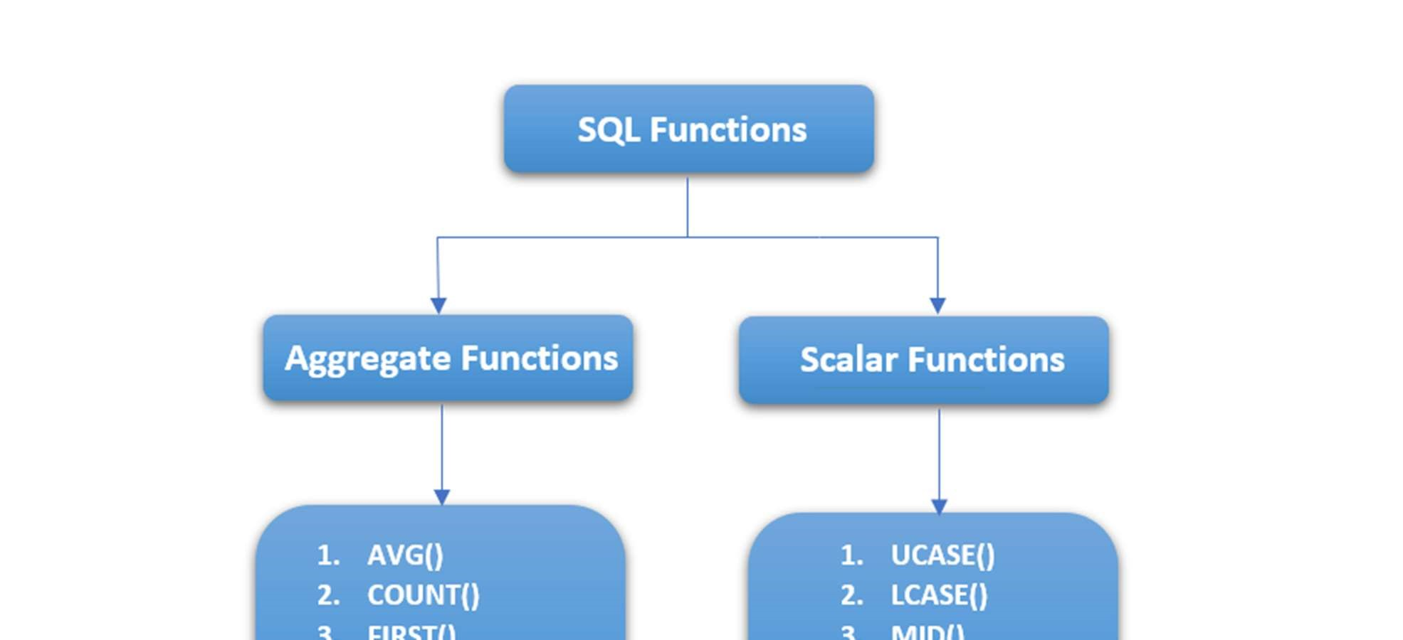

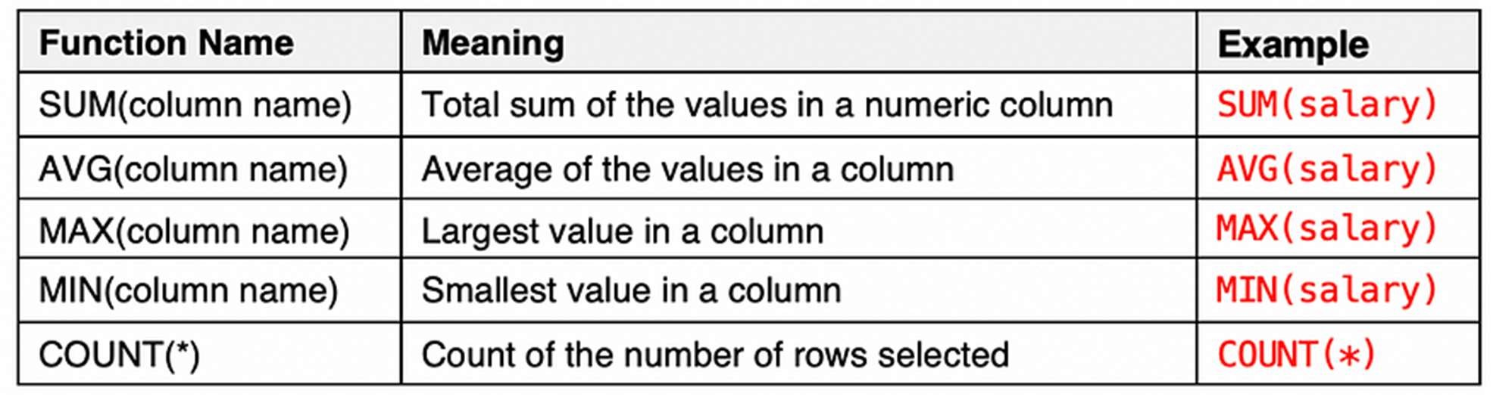

1. SELECT COUNT(column_name) FROM table_name WHERE condition;
2. SELECT AVG(column_name) FROM table_name WHERE condition;
3. SELECT SUM(column_name) FROM table_name WHERE condition;
4. SELECT MIN(column_name) FROM table_name WHERE condition;
5. SELECT MAX(column_name) FROM table_name WHERE condition;

QUERIES

* 1. Count the total number of employees.

* 1. Find the average salary of all employees.

* 1. Find the highest salary among all employees

* 1. Count the number of employees in each role.

* 1. Calculate the overall sum of hours worked on projects.   
     A white background with black text

     AI-generated content may be incorrect.

* 1. Count the total number of projects.   
     A black text on a white background

     AI-generated content may be incorrect.
  2. Calculate the average number of dependents for each employee.

* 1. Find the project with the highest total hours worked.

* 1. Find the earliest start date of employees in each department.

* 1. Retrieve the total salary spent by each department.

* 1. Average Salary of Employees in Each Department:

* 1. A screenshot of a computer

     AI-generated content may be incorrect.Calculate the total hours worked on projects by each employee.   
     RESULT

Thus the Queries using Aggregate functions were performed successfully and executed.

EXP NO: 8

Implementation of Order By, Group By & Having clause

AIM

Implementation of Order By, Group By & Having clause

THEORY

GROUP BY

The GROUP BY statement groups rows that have the same values into summary rows, like "find the number of customers in each country".

The GROUP BY statement is often used with aggregate functions

(COUNT(), MAX(), MIN(), SUM(), AVG()) to group the result-set by one or more columns.

SELECT column_name(s) FROM table_name

WHERE condition

GROUP BY column_name(s)

ORDER BY column_name(s);

Example: SQL> SELECT EMPNO, SUM (SALARY) FROM EMP GROUP BY EMPNO;

GROUP BY-HAVING :

The HAVING clause was added to SQL because the WHERE keyword could not be used with aggregate functions. The HAVING clause must follow the GROUP BY clause in a query and must also precede the ORDER BY clause if used.

SELECT column_name(s)

FROM table_name

WHERE condition

GROUP BY column_name(s)

HAVING condition

ORDER BY column_name(s);

### Example : SELECT COUNT(CustomerID), Country FROM Customers GROUP BY Country HAVING COUNT(CustomerID) > 5;

ORDER BY:

This query is used to display a selected set of fields from a relation in an ordered manner based on some field.

SELECT column1, column2, ...

FROM table_name

ORDER BY column1, column2, ... ASC|DESC;

Example: SQL> SELECT empno, ename, job FROM emp ORDER BY job;

QUESTIONS

1. Order Employees by Salary in Descending Order

1. Order Companies by Total Employees in Ascending Order

1. Find Companies with More Than 50 Employees

1. Count the number of employees in each city.

1. Find the total salary paid by each company

RESULT

Studied and implementation of Order By, Group By& Having clause.

Expt No 9

Implementation of set operators nested queries, and join queries

AIM

Implementation of set operators nested queries, and join queries

THEORY

Set Operators And Nested Queries

A subQuery is a form of an SQL statement that appears inside another SQL statement. It is also termed as a nested Query. The statement contains a subQuery called a parent statement. The rows returned by the subQuery are used by the following statement.

Union Clause:

The user can put together multiple Queries and combine their output using the union clause . The union clause merges the output of two or more Queries into a single set of rows and columns. The final output of union clause will be

Output: = Records only in Query one + records only in Query two + A single set of records which are common in both Queries.

Syntax:

SELECT columnname, columname FROM tablename 1 UNION SELECT columnname, columnname From tablename2;

Intersect Clause:

The user can put together multiple Queries and their output using the interest clause.

The final output of the interest clause will be : A single set of records which are common in both Queries

SELECT columnname, columnname FROM tablename 1 INTERSECT

SELECT columnname, columnname FROM tablename 2;

Minus Clause:

The user can put together multiple Queries and combine their output

Output:= records only in Query one

Syntax:

SELECT columnname, columnname FROM tablename 1 MINUS

SELECT columnname, columnname FROM tablename 2

Join queries

Joint Multiple Table (Equi Join): Sometimes we require to treat more than one table as though to manipulate data from all the tables as though the tables were not separate objects but one single entity. To achieve this we have to join tables. Tables are joined on columns that have data type and data within tables.

The tables that have to be joined are specified in the FROM clause and the joining attributes in the WHERE clause.

1. Cartesian product/Cross Join

The CROSS JOIN keyword returns all records from both tables (table1 and table2).

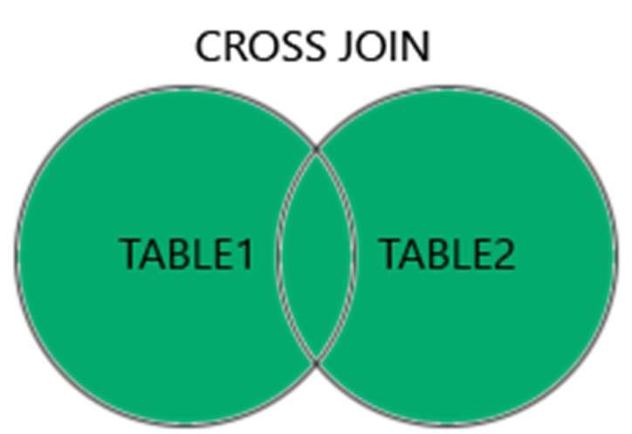

CROSS JOIN Syntax

SELECT column_name(s) FROM table1

CROSS JOIN table2;

1. Inner Join:

The INNER JOIN keyword selects records that have matching values in both tables.

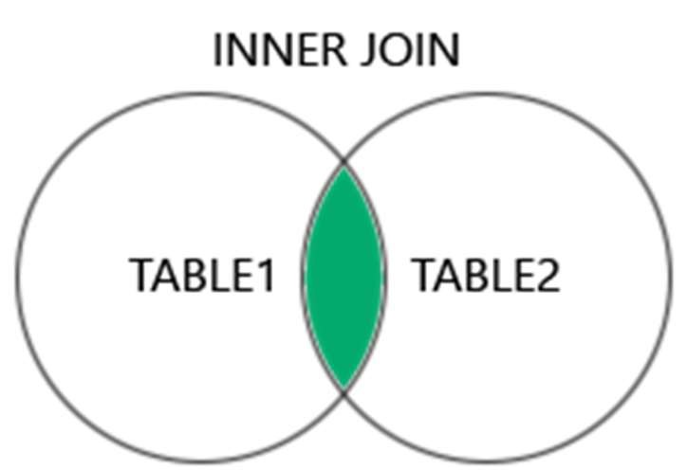

INNER JOIN Syntax

SELECT column_name(s)

FROM table1

INNER JOIN table2

ON table1.column_name = table2.column_name;

1. Left Join:

The LEFT JOIN keyword returns all records from the left table (table1), and the matching records (if any) from the right table (table2).

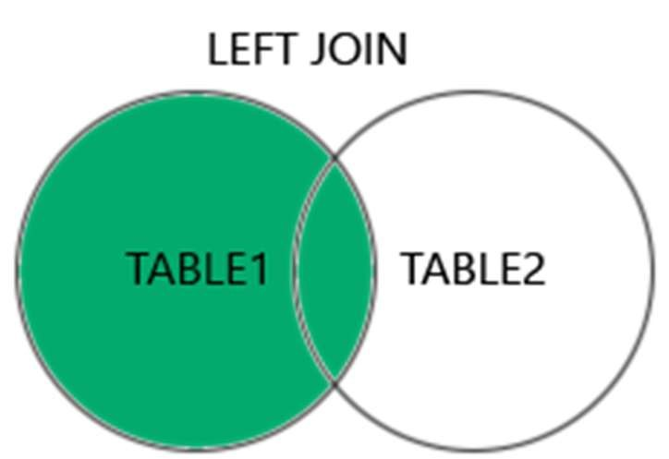

LEFT JOIN Syntax

SELECT column_name(s)

FROM table1

LEFT JOIN table2

ON table1.column_name = table2.column_name;

1. Right Join:

The RIGHT JOIN keyword returns all records from the right table (table2), and the matching records (if any) from the left table (table1).

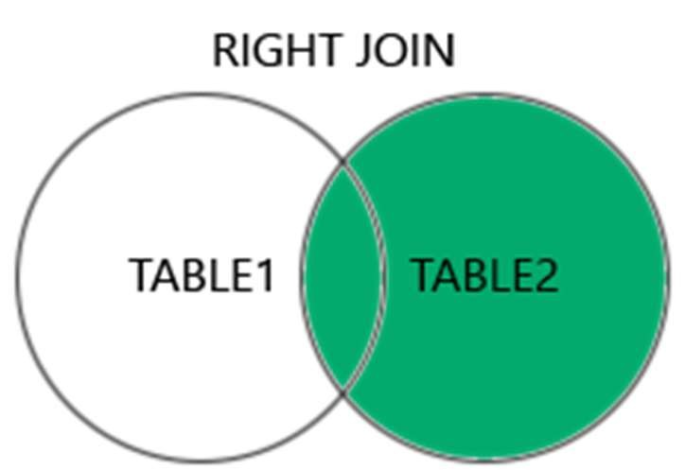

RIGHT JOIN Syntax

SELECT column_name(s)

FROM table1

RIGHT JOIN table2

ON table1.column_name = table2.column_name;

### Examples

Inner Join:

1. Retrieve the name of each employee along with the name of their department.

SELECT Employee.Name, Department.Name FROM Employee

INNER JOIN Department ON Employee.DepartmentID = Department.DepartmentID; Cross Join:

1. Retrieve all possible combinations of employees and projects. SELECT Employee.Name, Project.Name FROM Employee CROSS JOIN Project; Left Join:
2. Retrieve all employees along with their assigned project names (if any).

SELECT Employee.Name, Project.Name FROM Employee

LEFT JOIN ProjectAssignment ON Employee.EmployeeID = ProjectAssignment.EmployeeID LEFT JOIN Project ON ProjectAssignment.ProjectID = Project.ProjectID; Right Join:

1. Retrieve all projects along with the employees assigned to them (if any).

SELECT Project.Name, Employee.Name FROM Project

RIGHT JOIN ProjectAssignment ON Project.ProjectID = ProjectAssignment.ProjectID

RIGHT JOIN Employee ON ProjectAssignment.EmployeeID = Employee.EmployeeID;

QUESTIONS

* 1. Retrieve the names of employees and their corresponding project names for all employees who are currently assigned to a project.

* 1. Get the names of departments along with the total salary of employees in each department.   
     A screenshot of a computer

     AI-generated content may be incorrect.

* 1. Get a list of all department names along with all project names without any specific relationship. A screenshot of a computer program

     AI-generated content may be incorrect.

* 1. List all employees and their assigned project names, including those who are not assigned to any project.   
     A screenshot of a computer program

     AI-generated content may be incorrect.

* 1. Show all departments and the number of employees in each department, even if there are no employees. A screenshot of a computer

     AI-generated content may be incorrect.
  2. Retrieve all project names and the names of employees assigned to them, including projects without any assigned employees.   
     A screenshot of a computer

     AI-generated content may be incorrect.

Result

Studied and implemented set operators, nested queries and Join queries.

EXP NO: 10

Practice of SQL TCL commands like Rollback, Commit, Savepoint

AIM

Practice of SQL TCL commands like Rollback, Commit, Savepoint

THEORY

TRANSATIONAL CONTROL LANGUAGE (TCL): A transaction is a logical unit of work. All changes made to the database can be referred to as a transaction. Transaction changes can be mode permanent to the database only if they are committed a transaction begins with an executable SQL statement & ends explicitly with either role back or commit statement.

COMMIT

The basic syntax for using a COMMIT command in SQL is as follows :

BEGIN;

{a set of SQL statements};

COMMIT;

A more simplified version of syntax for other relational databases like MYSQL is as follows : {a set of SQL statements};

COMMIT;

SAVE POINT & ROLL BACK:

Save points are like marks to divide a very lengthy transaction to smaller once. They are used to identify a point in a transaction to which we can latter role back. Thus, save point is used in conjunction with role back.

Syntax: SQL>SAVE POINT ID; Example: SQL>SAVE POINT xyz; ROLL BACK:

A role back command is used to undo the current transactions. We can role back the entire transaction so that all changes made by SQL statements are undo (or) role back a transaction to a save point so that the SQL statements after the save point are role back.

Syntax:

ROLE BACK( current transaction can be role back)

ROLE BACK to save point ID;

Commit

In MySQL, the statement SET autocommit=0; is used to disable the autocommit feature. By default, autocommit is enabled, which means that each SQL statement is automatically committed as a separate transaction.

*/

SET autocommit=0;

/*

QUESTION 1: Create a transaction that inserts a new employee record and updates the salary of an existing employee. Ensure that both operations are successful before committing the transaction."

QUESTION 2: Within a transaction, create a savepoint after inserting a new project. Rollback to the savepoint if an error occurs during subsequent operations

Question 3: Start a transaction and within it, begin a nested transaction. Insert a new department and update the name of an existing department. Commit the nested transaction, and then either commit or rollback the outer transaction based on specific conditions

Question 4: Start a transaction and insert new records into multiple tables. Intentionally introduce an error, and if the error occurs, rollback the entire transaction.

QUESTION 4: Within a transaction, create multiple nested save points and perform operations. Rollback to a specific save point if an error occurs in the nested operations

RESULT

EXP NO: 11

Practice of SQL commands for creation of views and assertions

AIM

Practice of SQL commands for creation of views and assertions

THEORY

Views in SQL are kind of virtual tables. A view also has rows and columns as they are in a real table in the database. We can create a view by selecting fields from one or more tables present in the database. A View can either have all the rows of a table or specific rows based on certain condition.

CREATE VIEW view_name AS

SELECT column1, column2,...

FROM table_name

WHERE condition;

QUESTIONS

1. Create a view that includes essential details about each employee.

1. Create a view that displays information about project assignments for employees

1. Create a view showing employee details along with information about their dependents.

1. Create a view that combines project details with the corresponding department information

1. Create a view that summarizes information about each department, including the total number of employees and total salary.

1. Check data in view Emp-Sal

1. Search view for a given employee

1. UPDATE Emp View

1. Check the updated data in view

1. Check if the source table is updated or not

1. Update Base table, and check if View is updated or not

1. Check if View got changes

1. Delete View

1. Drop Base Table

1. Verify deletion of base table will automatically delete view



RESULT   
Studied and implemented Views in SQL.

### ANNEXURES

PROGRAM OUTCOMES (POs)

Engineering Graduates will be able to

1. Engineering knowledge: Apply the knowledge of mathematics, science, engineering fundamentals, and an engineering specialization to the solution of complex engineering problems.
2. Problem analysis: Identify, formulate, review research literature, and analyze complex engineering problems reaching substantiated conclusions using first principles of mathematics, natural sciences, and engineering sciences.
3. Design/development of solutions: Design solutions for complex engineering problems and design system components or processes that meet the specified needs with appropriate consideration for the public health and safety, and the cultural, societal, and environmental considerations.
4. Conduct investigations of complex problems: Use research-based knowledge and research methods including design of experiments, analysis and interpretation of data, and synthesis of the information to provide valid conclusions.
5. Modern tool usage: Create, select, and apply appropriate techniques, resources, and modern engineering and IT tools including prediction and modeling to complex engineering activities with an understanding of the limitations.
6. The engineer and society: Apply reasoning informed by the contextual knowledge to assess societal, health, safety, legal and cultural issues and the consequent responsibilities relevant to the professional engineering practice.
7. Environment and sustainability: Understand the impact of the professional engineering solutions in societal and environmental contexts, and demonstrate the knowledge of, and need for sustainable development.
8. Ethics: Apply ethical principles and commit to professional ethics and responsibilities and norms of the engineering practice.
9. Individual and teamwork: Function effectively as an individual, and as a member or leader in diverse teams, and in multidisciplinary settings.
10. Communication: Communicate effectively on complex engineering activities with the engineering community and with society at large, such as, being able to comprehend and write effective reports and design documentation, make effective presentations, and give and receive clear instructions.
11. Project management and finance: Demonstrate knowledge and understanding of the engineering and management principles and apply these to one’s own work, as a member and leader in a team, to manage projects and in multidisciplinary environments.
12. Life-long learning: Recognize the need for, and have the preparation and ability to engage in independent and life-long learning in the broadest context of technological change.